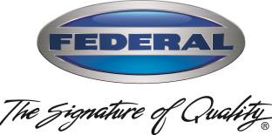
Doug Haworth Federal Industries
VP Sales & Marketing 215 Federal Ave,
Belleville, WI 53508

January 13, 2022
To: Federal Key Customers
RE: 2022 Price Announcement
Federal has completed a careful evaluation of our costs which includes key materials such as stainless steel, OEM components, etc. Similar to other manufacturers, we have seen large increases from our supply chain. While we have made every effort to reduce the impact through strategic negotiations, we have incurred several significant increases.
Due to these facts, pricing for merchandisers on average will increase by 7%.¹ Each series of merchandisers has been evaluated on their own merit for price increases based on the amount of stainless steel and OEM components affected by the increases noted above and have been adjusted accordingly. More details will be provided over the next week. Optional accessories will also have a price increase of 7%, on average¹.

¹ Increases may vary by product line, model and size.
Prices will be become effective on February 12, 2022.
We will price protect current 2021 pricing for thirty days. The pricing still includes a standard warranty of one-year parts, one-year labor, and a five-year motor compressor on self-contained refrigerated displays.
To announce the 2022 Price Schedule, we will be sending a cover letter, price schedule and price protection policy statement to all our current accounts. We will also send a PDF version of Price List with new pricing ASAP. Additionally, AutoQuotes will be updated by February 12, 2022.
If you have any questions or concerns, please feel free to contact me or your regional Sales Director.
Request for additional price lists should be emailed to Jackie Ceithamer (jceithamer@federalind.com) in our Marketing Department.
Sincerely,

Doug Haworth,
Doug Haworth
VP Sales & Marketing

