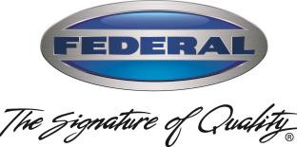
Doug Haworth Federal Industries
VP-General Manager 215 Federal Ave,
Belleville, WI 53508

June 16, 2022
To: Federal Key Customers
RE: 2022 Price Announcement
Federal has completed a careful evaluation of our costs which includes key materials such as stainless steel, OEM components, etc. Similar to other manufacturers, we have seen large increases from our supply chain. While we have made every effort to reduce the impact through strategic negotiations, we have incurred several significant increases.

Based on the notes above, Federal is announcing the following changes:

The Italian Glass product line will have a 3% price increase.

All other product lines will have a 7% price increase.

¹ Increases may vary by product line, model and size.
Prices will become effective on July 16, 2022.
We will price protect current 2022 pricing for thirty days. The pricing still includes a standard warranty of one-year parts, one-year labor, and a five-year motor compressor on self-contained refrigerated displays.
To announce this increase, we have sent a cover letter and price protection policy statement to all of our accounts. We will not be sending new hard copies of the price list with updated pricing. We will send an excel version of Price List with new pricing ASAP. Additionally, AutoQuotes will be updated by July 16, 2022.
If you have any questions or concerns, please feel free to contact me or your regional Sales Director.
Request for additional marketing materials should be emailed to Jackie Ceithamer (jceithamer@federalind.com) in our Marketing Department.
Sincerely,

Doug Haworth,
Doug Haworth
VP – General Manager

